Jenkins Assingment No:1
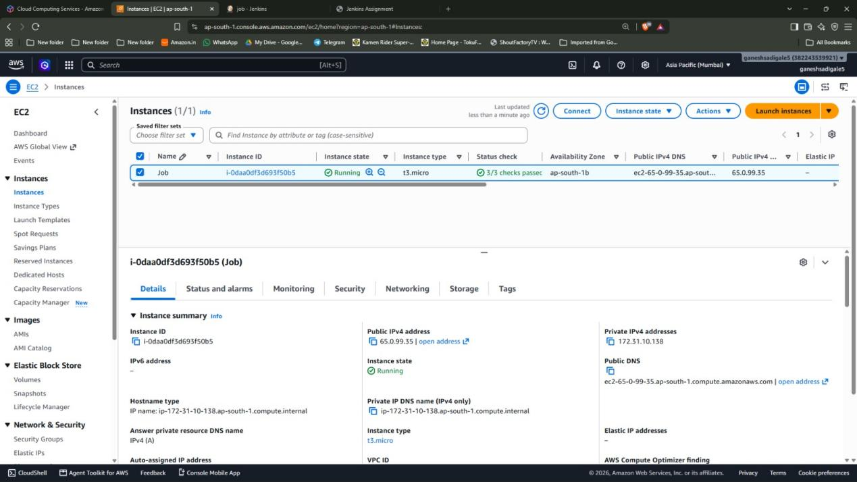

Step1: Created an EC2 instance named Job and connected a security group with port 22, 80 and 8080 allowed in inbound rules

Step2: Used putty to login into the instance

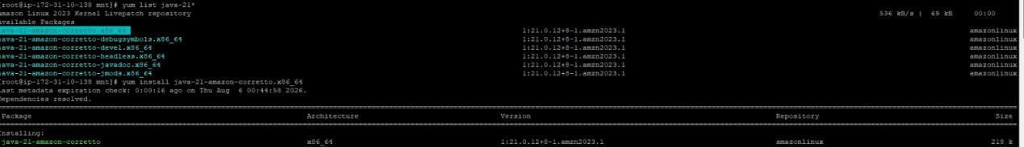
Step3: Downloaded Java-21 in the EC2

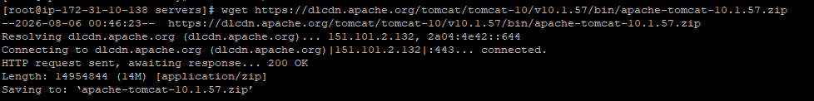
Step4: Downloaded Tomcat 10.1.57 zip file and unzip it

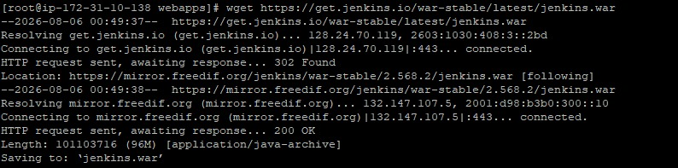
Step5: Downloaded Jenkins and used “./startup.sh” to start it

Step6: Used Public ip as “http://<public-ip>:8080/jenkins” to access Jenkins UI. There I first had to put the initial admin password which was found in “ /roots/.jenkins/secrets” name of the file was “initialadminpassword” which I used cat on

Step7: After doing that I created a admin account and did the setup for

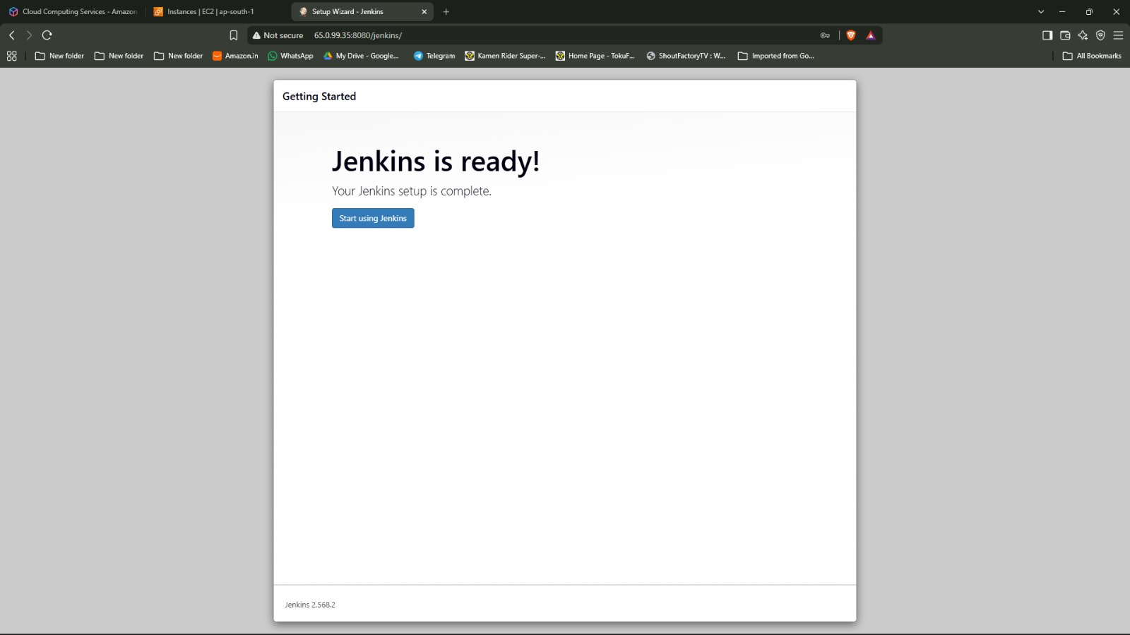

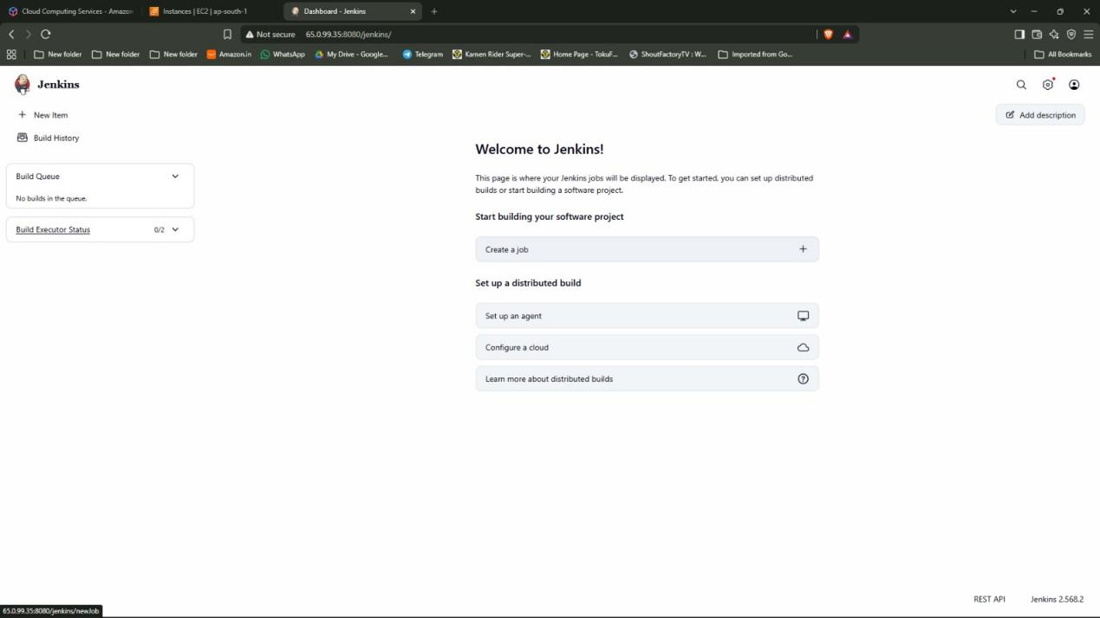

Step8: Selected the option “Create a job”

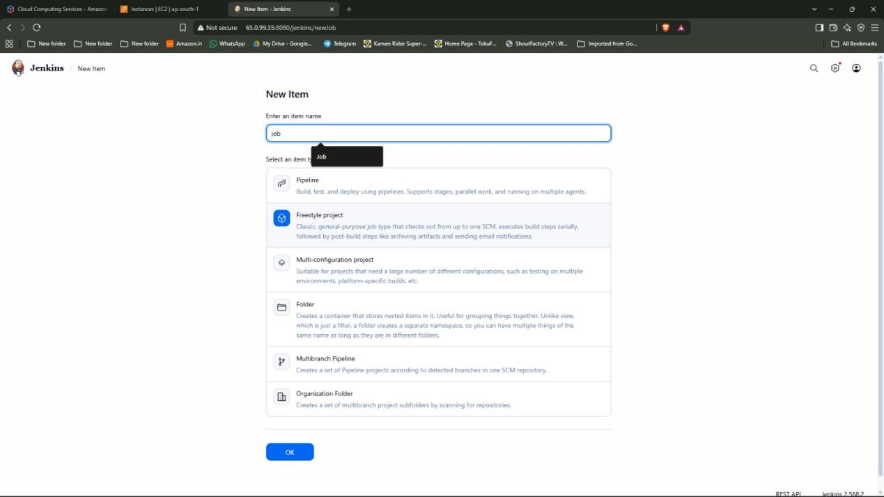

Step9:Entered the item name as “job”. Selected the option “Freestyle project”

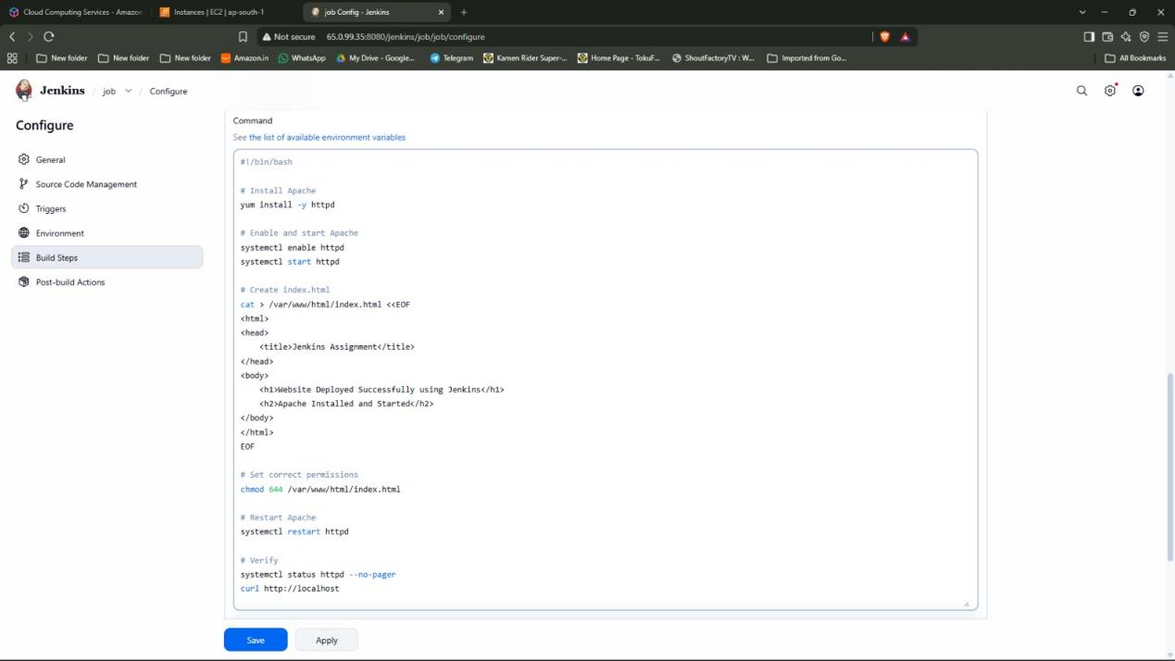

Step10: Selected the “Execute Shell” option in build and wrote the script then selected the option “Build now” which built the file

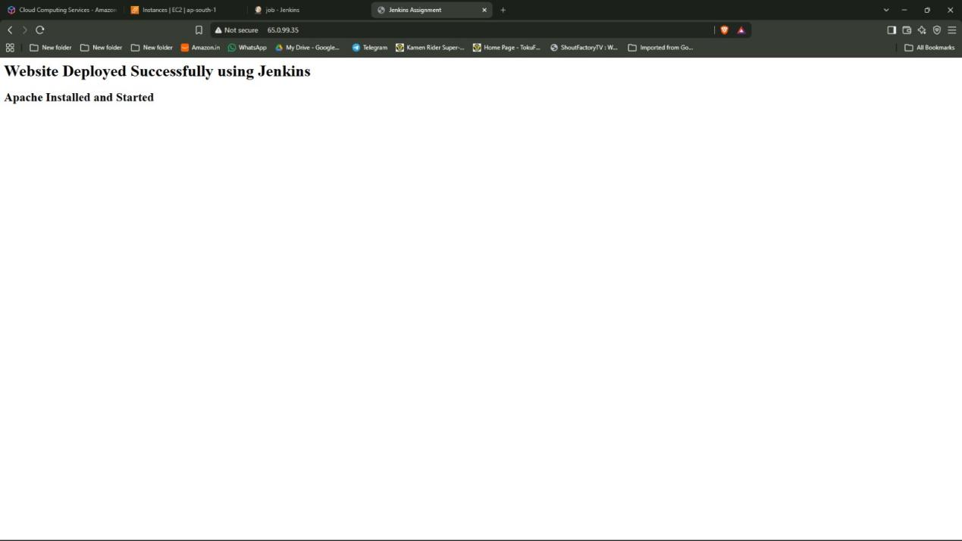

Step11: Used Public ip as “http://<public-ip>” to access the website

